Pilot Study of Moisture Control in Stuccoed Straw Bale Walls
Report to
Canada Mortgage and Housing Corporation
Don Fugler
from
Fibrehouse Limited
Bob Platts
Ottawa, 31 May 1997
INDEX
1/ INTRODUCTION
2/ THE PROBLEM
3/ THE PROJECT
4/ THE PILOT STUDY
5/ PILOT STUDY RESULTS AND FIRST COMMENTS
6/ DISCUSSION

INTRODUCTION
This report presents the findings of pilot work exploring straw bale house performance in resisting or controlling moisture. The field work was done in Quebec's Outaouais region, just north of Ottawa. Canada Mortgage and Housing Corporation helped fund this pilot work, which was carried out in May 1997.
Background:
Today's resurgence of interest in stuccoes straw bale building construction is driven by the realization that we must use resources much more efficiently - certainly including renewable resources, energy resources and "wastes", and pollute much less while so doing. The watchword is surely sustainability.
The building industry has not been doing very well: Even wood frame construction, clearly the most successful system based on renewable fibre, is consuming its forest resources at a questionably sustainable rate. The forest product innovators have been responding for decades, striving to assure sustainability and "value added" profitability by getting much more house from any tree, including what were "weed trees". Their innovations all take the form of "reconstituted wood" composites that yield more from less, but all at a price in terms of energy, money and pollution.
The remarkable innovators of one hundred years ago, the "folk engineers" who devised the Nebraska Straw Bale load bearing house walls, were simply using the resources they had: straw and the new horse-drawn straw baler. Their watchword was survival; their ingenuity led to a singular model of sustainable and non-polluting housing production. Their handsome houses still serve well.
Today's engineers are striving to simplify and streamline the Nebraska Straw Bale wall building method, make it even more resource-efficient in material, labour and energy terms, and ensure enduring performance as its usage spreads far indeed from the dry plains of Nebraska. We recognize its strengths and we can see it becoming a substantial market for our "waste" straw resource. Its structural, thermal, and fire resistance performance are exemplary. Our concern is the old one, the nemesis of cellulose fibre that is continually fought in wood frame housing: moisture.
THE PROBLEM
The problem addressed in this project is to determine the nature and severity of the moisture threats to the durability of the stucco-strawbale sandwich wall including modern stucco cases, and to do that well enough to allow designers and building authorities to deploy this building method with surety and to its full potential.
On the one hand, plastered straw bale house construction offers a long and successful performance record - but under rather ideal conditions: 100 years on the dry plains of Nebraska. On the other hand, experience with wood frame constructions as well as wood fibre and other cellulose fibre materials has proven that the accumulation and retention of excessive moisture can degrade their performance and render them unserviceable in just a few years.
Further, it is just those constructions that feature stucco finishes that are now seen as especially trouble-prone. And the presence of full-thick insulation and questionable drainage/drying characteristics always raises more concerns about handling moisture. As the Nebraska wall system has ventured into damper climes of wind-driven rain - Nova Scotia for example - the problem of entrapped moisture has already asserted itself where detailing and/or skin materials were no match for the severe exposures. Where the straw stays too wet well into summer warmth, rot will follow.
Finally, today's stuccoes often feature a high proportion of portland cement, and that is adding another dimension to our moisture concerns: alkali attack. Certain alkalies in portland cement are now known to attack some cellulose fibres quickly and decisively, perhaps even where the moisture cycling is kept within fairly low bounds that would not lead to rotting. Does such attack extend significantly to whole straw? To one or all cereal straws? Does it degrade the bond between the straw and the cement matrix? Must such cement-rich stuccoes be avoided or specially addressed? How do the modern shotcretes, that the straw bale movement so badly needs, affect the straw fibre and bond: does their "lock up" of those alkalies by their silica fume content alleviate the problem well enough?
THE PROJECT
In the face of so many variables and unknowns, the design of a short term laboratory study to predict long term performance and "threshold" moisture limits would be a daunting task. Fortunately the long term laboratory is in place and has decades of results ready to be revealed: "the field is the laboratory". In dry climates and wet, hot and cold, stuccoed straw bale houses number in the hundreds and are often sheltering successive generations. Further, some recent and well-known Quebec examples using portland cement mortars are already ten years old and in "moisture loaded" exposures. We seek to resolve the moisture issues quickly enough and well enough by going into the field and into the walls.
Since we know too little about the stock and the variables to design anything like a statistically representative study, we set out to conduct a pilot "worst case" study. The parallels with full-thick-insulated wood frame houses and certain masonry and stuccoed houses are fairly strong, and the extensive field studies in Canada - supporting and supported by the lab and analytical studies - tell us what likely comprises "worst case" and even the telltale signs to look for, of trouble within.
Clearly, a "worst case" study comes out definitively positive where even the weakest detail in the supposedly overloaded exposure is found to perform adequately over the useful lifetime of the whole building. Some such studies have resolved controversy just that clearly and easily. It's a little more difficult but more often necessary to develop and interpret the results where such worst case results are bad; this is what faces us now. But we know that troubled spots in walls are juxtaposed with neighboring areas which, theoretically and in fact, are somewat less "loaded" and perform adequately forever. Thus in practically every "worst case" we have our controls of a sort: we can dig into close-by untroubled areas and adequately define the threshold conditions.
THE PILOT STUDY Scope and Method:
The pilot has been conducted in the nearby Outaouais region of Quebec to help verify and define the moisture concerns as discussed above, and to help develop a method and protocol for widespread study if needed. We have explored means of moisture probing, sample removal, assessment and recording, as well as repair and make-good. The pilot encompassed two "worst-case" constructions and one that would have been expected to be sound and dry. The work can be summarized as follows:
Task 1:
Working on a stuccoed straw bale wall, try various cutting tools, sample size and shape, extraction, recording and repair/make-good methods; develop the test procedure.
- Rather than using someone's house to trace our learning curve, we were fortunate to access a one-of-a-kind ruin for this trial-and-error exercise: Brad Robinson's pioneer "Biocrete" building experiment on the banks of the Gatineau. A sandwich structure featuring a low-density core of various fibres bonded with a light soil cement, and skins of more dense, more cement-rich fibre-soil-cement and some areas of portland cement caps and stucco, this 6-year old experiment gave us field findings far beyond the value of trying our tools and cutting patterns. The results are given below, coded "X" for exploratory.
Task 2:
Locate candidate houses.
- This and Task 3 would be among the biggest tasks in a widespread study. But not here: Brad, a "folk engineer" if anyone merits the term, knows the houses and owners and in some cases was involved in the construction. Four were identified, 7 to 10 years old, and two were selected as best candidates for the pilot work to this point.
Task 3:
Obtain owner's/householder's permission for each case. This took some time and diplomacy for the two houses, but not too much thanks to the Robinson factor. In addition, a 7 year old greenhouse featuring walls of both Biocrete and some essentially stucco-straw bale sections was obtained for inspection: built by Brad.
Task 4:
Survey the walls and interpret exposures, details and telltales to suggest dry zones and "worst case" wetted zones.
- We've conducted field moisture studies of some 16000 houses in the past couple of decades or so. (Admittedly, about 14000 were done by infra-red thermography in the notable cross-Canada survey in the mid-80s - toward the end of which we scarcely needed the thermography to "find water". The other 2000 or so houses were inspected and probed in various trouble-shooting field studies from coast to coast and into the high Arctic. We know how to assess where the "annual wetting regime" from outdoor or indoor sources is greater than, or not sufficiently weaker than, the "annual drying regime", so that excess moisture can accumulate and be retained long enough and into sufficiently high seasonal temperatures to rot wood - or straw. We also know the faint surface "telltales" that usually accompany such trouble within.
Task 5:
Cut and remove say 100mm squares or equivalent circles of the exterior stucco - and the straw anchored in each - from one or more apparently dry and two apparently more wetted zones per house.
- A 7-inch-blade grinder had been proven best in Task 1, cutting 4 inch squares as anticipated. (A hole saw proved slow and also imposed torque on the stucco-straw interface as it cut through the last thickness of stucco.) As the sampling progressed we finally favoured a triangular cutout, reducing the cutting, and we refined the break-through technique to transfer no shear force or motion into the straw.
The biggest problem is the thick cloud of silica-cement dust: Clearly the sampling shouldn't be done indoors (we inspected only from outside); dust mask, goggles and a fan or good breeze are mandatory even to see the cutting work; the cut lines should be marked boldly with a marker pen; and householders and children should be told what to expect.
Task 6:
Moisture-probe into the wall through each such opening, using an in-line electric resistance moisture probe designed for straw, taking readings progressively through the straw bale.
- The Delmhorst probe that's widely used for straw is actually calibrated for hay. Its booklet says it's calibration was largely done with alfalfa but it's right enough for other varieties of hay. David Eisenberg of DCAT in Arizona has determined that it reads falsely high in straw, but not by much. The meter worked consistently and repeatably in the wheat and barley straws encountered here, if its tip was wiped often: saturation is visibly and squeezably saturation and dry is dry, and the in-between conditions all seemed to read realistically. Temperature corrections are given in the booklet for hay, and applied here directly.
Task 7:
Inspect and photograph the slices immediately, and bag them for such further analysis as may be appropriate, probably including tensile appraisal of the straw and bond, and perhaps fungal analysis.
- We have photographed, hand-tested and smelled the samples conclusively enough for the pilot, and coded and bagged them; but haven't devised a tensile tester for pullout, and that may be desirable. We will seek counsel on fungal and perhaps other analysis that may add value.
Task 8:
Assess evidences of main moisture sources, strengths and paths or transfer mechanisms impinging most directly on each point, to help assess the pilot results and draw useful conclusions to this point.
PILOT STUDY RESULTS AND FIRST COMMENTS
Photos of some of the most meaningful samples are shown, with brief notes on condition, apparent moisture exposure history, and first comments. Recall that we look hard for "worst case". Photo codes refer to field notes, S means sample.
Task 1's exploratory cases proved valuable:
Figs. 1 & 2, photos X3-3-1 & X5-5-1: 6-yr-old Biocrete experimental structure described above in Task 1.
Fig 1: The east facing wall - most exposed to driving rain - is sound and dry under its concrete cap with proper drip edge; while the south facing wall to the right, mostly under an amply wide concrete cap but the reverse of drip edged, is badly eroded. (The hole and two horizontal cuts are from our first trials of sample extraction.)
Fig. 2: The latter wall has just been knocked down for inspection, exposing the bottom of its straw bale core (straw used here only) where it had rested on soil-cement mortar on the ground. The straw is super-saturated and rotting, fibres very weak. Moisture from below as well as above clearly exceeds the drying regime despite the generous water vapour "breathability" of the deeply eroded soil-cement skins.
Figs 1 & 2, all inspectable points: The cement-rich skins and caps have not caused extra deterioration of fibre at the interface, and indeed appear to have preserved the fibre bright and sound where it's encased within the skins and caps. (Mostly shredded wood is visible in Fig. 1, straw in Fig 2.)
Other exploratory case (photos on file): The greenhouse noted earlier also proved valuable,
although we did not obtain clear permission to cut into it. Truck damage to corners and along one wall made some of the fibre-soil-cement and raw straw core visible and inspectable. Some such spots were exposed to frequent wetting from rain and snow but generally could drain and dry fairly freely. Only those spots where water could pool or linger revealed considerable deterioration of the shredded wood and straw. Here too, the cement-rich mortar and stuccoes seemed to preserve the fibre they encased, and no more deterioration was seen at their interface with the fibrous core than further into the fibre.
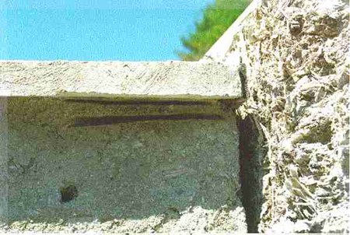
Figure 1

Figure 2 A crawl space foundation case:
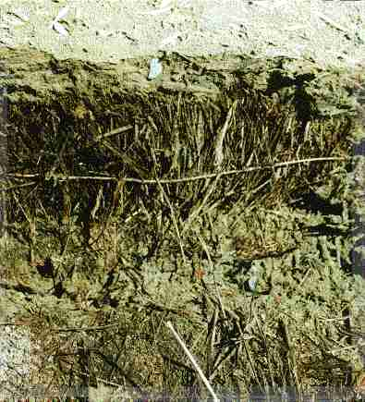
Figs. 3 & 4, P6-S1-13 & P5-S2-12: 6 yr. old straw bale foundation footed on thin layer of shredded straw-soil-cement mortar 6 in. below final grade, which in turn was borne by rubble stone drain/capillary break in deep trench, Frank Lloyd Wright style. No polyethylene film or other dampproof course separated the straw from the trench below. The trench is well sloped and drained to daylight, and must handle a lot of water much of the year since the (wood frame) summer cottage is on a hillside with considerable hill above it.
Selected samplings are well under a fully closed porch addition. Temperature 8 C. The skins are composed of the shredded straw-soil-cement slurry applied to the bales about 1-1/2 in thick and faced with a formed-in-situ finish of cement-rich mortar, at least equally thick, exterior and interior. This dense finish would be rather impermeable to water vapour, like the good concrete it essentially is, and it appears free of cracks; the crawl space is not lined but runs cold: it must contribute little to the moisture in the straw but does block one drying route.
What we have, though, is an upside-down concrete bottle with its open mouth a few inches above water or vapour at 100 % RH - a humidifier that's warmer than the outer zone of the bottle's interior much of the winter. And it's filled with straw.
Fig. 3: Sampling at 3 ft above grade, into a bale which is separated from the 100% RH trench by at least two horizontal layers of cement-rich mortar between the bales; S1. (Gagne style construction, but built by others; structure is ok, not relying on bond to straw.) Cement-rich outer finish broke away from inner slurry, which itself broke up so no sample obtained with straw bonded into slurry. Straw is moist and deteriorating as can be seen, and is weak in tension. Moisture meter reading (MMR) 37-42 through the bale: about 38-43 % MC corrected for temperature. Saturated. Smells just slightly musty.
Fig. 4: Sampling just above grade, below the first spot; S2. Lacy white mould indicates advanced rotting; straw very weak. But note bright, sound straw in the upper left corner of the shredded straw-soil-cement slurry sample, which this time stayed intact. MMR off scale, straw supersaturated.
Figure 3
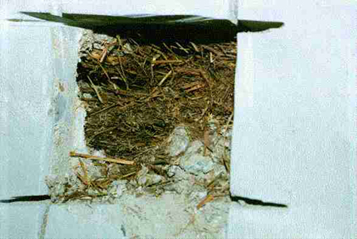
Figure 4
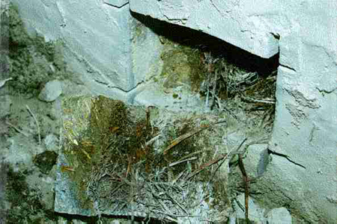
A 2-storey house case:
Figs. 5-10, respectively P3-S3-15, P10-S4-17, P15-S6 over S4-22, P12-S6-18, P14-S6-21 and P17-S8-24: 10 yr old Gagne type on slab.
South face shows clearest telltales beneath apparently unflashed windows with no drip edge, but this faces driveway and highway so we left it unprobed. (Such observations and sampling results are pointed out to the householder, with guidance on how to fix.) Less obvious moisture paths and some telltales were noted on the east and north facing walls, respectively the most and perhaps least exposed to driving rain. Light rain this day, and just 4 C.
Fig. 5: East wall, one storey up, under a spaced-board deck supported on cantilevered floor joists: S3. Unreinforced stucco already cracked due to joists, which was one reason this spot was chosen. But there was no sign of water entry, and the open cracks would aid the drying action. The straw, placed between the joists in flakes oriented with the wall plane rather than transversely, is bright and sound throughout, and well bonded where the stucco encased it despite its parallel lie. Lime rich stucco mix. MMR below scale right through the straw core area, i.e. less than 13% MC.
Fig. 6: North wall, under same wrap-around deck, sampling just above slab and, as it happens, just under a mortar bed between this bale and the one above; S4. Discovered that the bales had been limed before construction: the white in the straw is not mould. (The loose flake straw of Fig. 5 had not been limed.) And apparently all the stucco and mortar is lime rich, whereas we have read that the vertical and horizontal structural mortar in this type of wall construction is normally a cement-sand mix.
We think that the slab is not underlain by polyethylene nor is there such a barrier between it and the straw above. There are no obvious cracks in the stucco up to the roof overhang (3 ft.), and the deck above this north face sample area does not appear to induce much backsplash. But the straw is moist and musty-lime smelling, deteriorating. The lime dust seemed to nullify straw-stucco bond in some spots. MMR of 18 straight through bale, and 20-21 angling down to slab; adding 2 to correct for temperature, MCs are 20 to 23%. We return to this zone after a little more probing in the east wall.
Figure 5
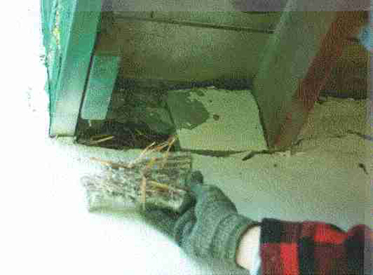
Figure 6
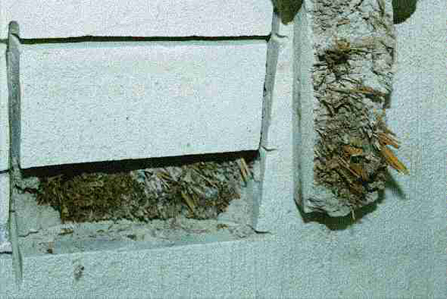
2-storey house continued, back to east face: Sample S5 cut under the lower south window on east wall, with little roof protection on this exposed gable end, and with no drip edge on window sill - more or less flush with stucco. (But no visible telltale of trouble within.) Sample 1 ft. up from slab. Cutting through 3-1/2 inches of solid lime-rich stucco proved troublesome. (The skins vary greatly in thickness; the earlier samples had 2 in thick skins.) The layered skin broke up with no clear sample with straw bonded into it, and in the soaking rain we forgot to photograph the apparently sound, sweet smelling straw within. But we did take MMRs right through to the 11-in. length of the probe: 19 near newly exposed surface, 13 through to the middle of the bale; correct to 21 and 15%, the latter probably a truer measure, being free of rain and wet probe effects.
Then returning to the north face to explore further a suspected slab effect (ground moisture, "rising damp" as its called in Britain):
Fig. 7: A further sample S6 is cut just above the Fig. 5 north wall sample S4; the photo shows both. (In between lies a thick layer of mortar separating the bales, Quebec style; that was cut into and later pried into as a further sample, showing that it is also a lime-rich mortar in this case. Again the straw impinging onto and into it was not affected, nor was there any clear indication that these transverse mortar layers in this type of construction act to wick water into the bales, as is a concern.) The photo records that the top sample, S6, is brighter and sounder in appearance than the one so close below, S4.
Fig. 8: Looking into S6. The lime in the straw shows as a grey powder; otherwise the straw looks, pulls and smells sound. The lime powder does seem to weaken or even prevent its adherence where the stucco encases it, but a mechanical bond is still present, Fig. 9. MMR 13 near surface, rising to 15 a couple of inches in and staying at that reading; temperature corrected to 15% and 17% respectively.
The straw is indeed drier and rot-free just a little further up from the slab, and with a thick layer of mortar intervening. In the absence of any visible flaw or source, we must suspect "rising damp" wicking up from an unprotected slab, perhaps placed on gravel which worked down into the mud or the mud up through it.
Figure 7
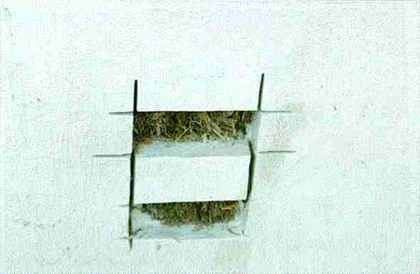
Figure 8
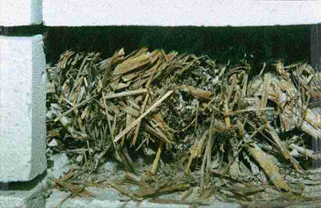
Figure 9
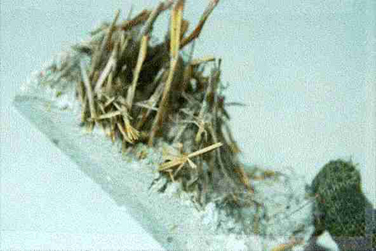
Fig. 10, below: S8, north wall, under corner of window sill flush with stucco surface, about 1-1/2 ft above slab; a faint dustmark smudge led us here. The inner bond coats of the 3 in. thick stucco broke up as shown, with little to tell of straw bond. Musty smelling, weak, moist straw in this 10 yr. old wall. MMR 25-25-22-20% probing straight through to full 11 in. probe length; angling downward toward slab, the MMRs became 25-30-35-30%. (Warmer today, 12 C: MMR=MC%.)
Figure 10
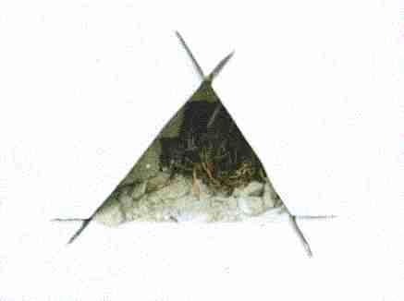
DISCUSSION
The few cases and their variance from whatever is "normal" in stuccoed straw bale construction do not convey defnitive conclusions, but we can offer the following with some confidence:
"Straw is not magic", as Don Fugler of CMHC said in support of this study, increasingly facing requests for support of everything including bale basement walls and bale insulation under slabs on grade. What's not done lightly with wood should not be done with straw...not yet, anyway.

- The troubled zones in the straw all seemed explainable after the fact: moisture sources, paths and entrapments result in the net annual wetting regime approaching or exceeding the net drying regime; straw staying moist enough into the summer warmth is rotting. (Wood held in the same moisture state and duration would rot similarly, we have observed, but would avoid or delay that condition in most of these cases if only because a wood frame wall drains better and the "net drying regime" is strengthened.)
- The results of this small sampling suggest that the alkaline stuccoes, whether lime rich or cement rich, do not attack the straw at the interface and indeed appear to preserve it where encasing it. But the cement rich stuccoes may well be too impermeable to water vapour - not "breathable" enough - to use freely as exterior skins in cold country... and the lime rich stuccoes too permeable to liquid water for driving rain country...
- Substantially troubled zones in the stuccoed bale walls were marked by faint surface telltales and perhaps generally can be found and remedied. Better yet, we think the problem of excessive moisture can be avoided altogether at the design and construction stage, although we would not be confident building stuccoed straw bale in all regions.
A much wider field project should be conducted across Canada and at least northern tier USA, further refining and using the method and procedure as developed in the pilot. The American stock would add value, providing evidence of performance under certain exposures over very long periods. While the pilot itself was on home ground, where our team is familiar with much of the stock and the individual builders and householders, we know that two of the toughest jobs for a broad study would be:
- Locate candidate houses: For much of this we would enlist the help of the main newsletters and Internet home pages in this field. There are hundreds of cases out there, a fair "network" to help find them, and some knowledgeable enthusiasts to help identify the more exposed or known trouble points.
- Obtain owner's/householder's permission: This wouldn't always be easy, especially where seeking access to the apparently troubled cases on which the study must rely. In our decades of experience mounting such field studies, we have found that up to half of householders don't want intrusive probing of their houses, especially where the findings might well be bad and market value might be hurt. But the owners here should be fairly willing candidates in the main: they are vested advocates of their unique approach to sustainable housing production; they tend to be do-it-yourself types, technically inclined and curious; they will understand that problems should be identified and are often addressable; and they don't intend to put their house on the market next year. The enthusiasts and the Internet are the tools to find them and to convey the nature and value of the field study, making the point as well that remedial advice will be offered.
The other tasks would probably be undertaken much as in the pilot study. We would further refine the sampling technique and equipment, perhaps to reduce noise and dust, read temperature and RH in the sample cavity, and measure straw tensile strength and straw-stucco bond in some consistent manner; and would more carefully use our indoor assessment routine to indicate any indoor moisture role if any (especially where interior window surface run-down gets into the wall). And then develop guidelines on building baled fibre houses to stay dry and sound.

